A Mini Project Report
On

FINDMYHOME WEBSITE



Submitted By

K.Dhanush 22B91A6187
M.Swamy 22B91A6196
M.Rahul 22B91A61A5
P.Harish 22B91A61C2

DEPARTMENT OF COMPUTER SCIENCE AND ENGINEERING (AIML)
S. R. K. R. ENGINEERING COLLEGE (A)
(Affiliated to JNTU, KAKINADA) BHIMAVARAM-534204
(2024-2025)

DEPARTMENT OF COMPUTER SECIENCE AND ENGINEERING (AIML)

S. R. K. R. ENGINEERING COLLEGE BHIMAVARAM



CERTIFICATE

This is to certify that this is a bonafide work on “FINDMYHOME WEBSITE” and has been submitted by K.Dhanush 22B91A6187, M.Swamy 22B91A6196, M.Rahul 22B91A61A5, P.Harish 22B91A61C2 as a MEAN Stack Technology (Module – I) laboratory report, in partial fulfilment of the requirements for the award of the Degree of Bachelor of Technology in Computer Science and Engineering (AIML), during the academic year 2024-2025. The candidate/s worked right under my supervision and guidance.

Internal Examiner Head of the Department
1.
2.

ACKNOWLEDGEMENT

We take immense pleasure in thanking Prof. K. Murali Krishnam Raju, beloved principal of S.R.K.R Engineering College, Bhimavaram, Dr. Bh. V. S. R. Raju esteemed Head of the Department and Dr. G N V G Sirisha program coordinator (AIML), for having permitted us to carry out mini project work in MEAN Stack Technology. We wish to express our deep sense of gratitude especially to our project guides Dr. K Aruna Kumari, Associate Professor and Miss. Ch Suma, Assistant Professor, for their guidance and useful suggestions, which helped us in completing the work, on time. Finally, yet importantly, we would like to express our heartful thanks to our beloved parents, faculty, my friends/classmates for their help, and our wishes for the successful completion of this project.

K.Dhanush 22B91A6187
M.Swamy 22B91A6196
M.Rahul 22B91A61A5
P.Harish 22B91A61C2

ABSTRACT

This project proposes the development of FindMyHome, an online room rental platform built using the MEAN stack (MongoDB, Express.js, Angular, Node.js). The platform bridges the gap between property owners and tenants by eliminating the need for brokers, thereby promoting transparency and direct interaction.
The system allows property owners to post listings through a simplified interface, including essential details such as property type (Single Room, 1RK, 1BHK, 2BHK, 3BHK), rent, furnishing status, and availability. Tenants can search and filter properties based on multiple parameters such as BHK type, budget range, tenant preference, furnishing status, and availability. Listings are also grouped under curated collections like “For Family,” “For Single Men/Women,” and “Company Lease.”
FindMyHome features dedicated login modules for users and owners with secure authentication. An in-site search bar enables location-based queries, and tenants can raise maintenance requests directly through their dashboards. Real-time updates on listings and activities enhance user interaction.
The frontend employs responsive design principles and FontAwesome icons for improved user experience across devices. Clean architectural planning, modular backend development, and intuitive Angular components contribute to performance, scalability, and security.
FindMyHome focuses on solving rental market inefficiencies by offering an end-to-end solution that supports verified listings, secure user access, and seamless property management. The success of the platform will be evaluated based on user engagement, listing quality, and reduction in broker dependency across urban and semi-urban regions.

TABLE OF CONTENTS

Sl. No. CONTENTS Page No.

- MODULES 2
- SOFTWARE REQUIREMENTS 3
- TECHNICAL STACK 4-6
- INTRODUCTION 7
- SAMPLE CODE 8-33
- SCREENSHOTS 33-40

MODULES
- Home page
- User Login page
- User Sign-up page
- Post Property page
- Services Page
- About page
- Maintenance page
- Updates page
- Booking page
- Room Details page

SOFTWARE REQUIREMENTS

- Text Editor: Visual Studio Code, Notepad
- Front End: HTML, CSS, JavaScript
- Back End: Angular js
- Databases: MongoDB
- Internet Browser: Google Chrome

TECHNICAL STACK

1. Frontend Development:
HTML (HyperText Markup Language)
It is the standard markup language used to structure and display content on the web. It organizes information into elements like headings, paragraphs, images, lists, and links using nested tags. HTML forms the semantic foundation of web pages, making them readable by browsers and accessible to users. It plays a crucial role in defining the hierarchy and meaning of content. HTML5 introduced support for multimedia, APIs, and improved semantics. It enables search engine optimization (SEO) through proper tag usage. HTML is also essential for form creation, which enables user interaction. It's designed to be extensible and works seamlessly with CSS and JavaScript. Whether it's a simple page or a complex application, HTML serves as the backbone of web development. As the web evolves, HTML remains a key technology for creating structured and interactive experiences.
CSS (Cascading Style Sheets)
It is the language responsible for defining the appearance and layout of web content. It works alongside HTML to control design elements like color, typography, spacing, and alignment. CSS uses selectors to target HTML elements and applies a set of rules to style them. It supports responsive design via media queries, adapting layouts across various screen sizes. Features like Flexbox and CSS Grid make it easier to build complex and fluid layouts. CSS also supports animations, transitions, and transformations for dynamic interfaces. It allows for separation of concerns by keeping styling independent from HTML content. The cascading nature allows multiple stylesheets and rules to work together through specificity and inheritance. CSS3 introduced modern visual enhancements that elevate user experiences. Overall, CSS is critical for ensuring consistency, accessibility, and visual engagement in web design.

JavaScript
JavaScript is a powerful, high-level programming language that brings interactivity to web pages. It runs in the browser and enables dynamic behaviors such as form validation, content updates, and animations. JavaScript can manipulate the DOM (Document Object Model) to alter page content and layout in real-time. It supports event-driven programming, allowing developers to handle user inputs and actions efficiently. With asynchronous features like Promises and async/await, JavaScript handles API calls and real-time data fetching smoothly. It has a rich ecosystem, with libraries (e.g., jQuery) and frameworks (e.g., React, Vue, Angular) that accelerate development. JavaScript is also used on the server side via Node.js, enabling full-stack development with one language. It supports object-oriented and functional programming paradigms, offering flexibility. JavaScript is constantly evolving with new ECMAScript standards that add modern features. It is indispensable for creating engaging, dynamic, and fully functional web applications.
2. Backend Development:
AngularJS
AngularJS is an open-source JavaScript framework developed by Google for building dynamic web applications. It extends HTML with custom directives and enables declarative data binding, simplifying UI development. AngularJS follows the MVC (Model-View-Controller) design pattern, promoting organized and modular code. Its powerful two-way data binding syncs model and view automatically, reducing boilerplate code. It includes dependency injection, which facilitates testing and reusable components. AngularJS supports routing, enabling the creation of single-page applications (SPAs) with client-side navigation. It enhances HTML's capabilities by turning it into a more expressive and readable format. AngularJS provides services and factories for data operations, promoting clean separation of logic. Though it's now succeeded by Angular (2+), AngularJS remains significant in full-stack JavaScript development. It allows seamless integration with REST APIs, making it an effective framework for frontend-backend interaction in modern web apps.
3. Database
MongoDB
MongoDB is a NoSQL, document-based database designed for flexibility, scalability, and performance. It stores data in JSON-like BSON documents, allowing nested structures and dynamic schemas. This makes it ideal for applications with unstructured or evolving data requirements. MongoDB scales horizontally through sharding, supporting large-scale applications with distributed data. It supports powerful querying with filters, aggregations, and indexing for high performance. MongoDB offers features like replication, automatic failover, and backups to ensure high availability. It’s schema-less, allowing rapid development without rigid table definitions. Developers can work with MongoDB using native drivers in languages like JavaScript (Node.js), Python, Java, and more. Its integration with popular frameworks and cloud services enables robust data handling in full-stack applications. MongoDB is particularly effective in real-time analytics, content management systems, and IoT platforms due to its speed and flexibility.

INTRODUCTION

The project "FindMyHome – A Smart Room Rental Platform" is a forward-thinking initiative aimed at transforming the rental housing experience in India. With the rising urban population and increasing demand for affordable rental spaces, the platform seeks to address key challenges such as broker dependency, lack of verified listings, and fragmented property information. It envisions a centralized, user-centric solution that connects property owners and tenants directly, ensuring transparency, convenience, and trust in the rental process. FindMyHome caters to a wide range of users including students, working professionals, bachelors, and families by offering tailored property collections and customizable search filters. Users can explore rental options based on their preferences such as property type, budget, furnishing status, and availability. The platform also enables owners to list properties effortlessly, making it easier to reach potential tenants without intermediaries. By promoting a secure, reliable, and accessible environment, the platform not only enhances the property discovery experience but also builds a trusted ecosystem for both tenants and property owners. Ultimately, FindMyHome aims to redefine how people search for and manage rental accommodations—making the process smoother, more efficient, and aligned with the evolving needs of India's diverse housing market

SAMPLE CODE
1. userlogin.html and usersignup.html:
<!DOCTYPE html>
<html>

<head>
<title>login</title>
<meta name="viewport" content="width=device-width, initial-scale=1.0">
<meta name="viewport" content="width=device-width, initial-scale=1.0">
<link rel="stylesheet" href="./../css/login.css"/>
<script src="https://kit.fontawesome.com/61d1b80f50.js" crossorigin="anonymous"></script>
</head>

<body>

<!-- ----------------navbar-------------- -->
<nav>
<h1 class="brand-heading-1">FindMyHome</h1>
<img src="../img/home.png" alt="" class="home-png">
<div class="nav-items">
<a href="/index.html"><button class="post-btn">Home</button></a>

<a href="./post_property.html"><button class="post-btn">Post Property</button></a>
<a href="./usersiginup.html"><button class="post-btn">Sign Up</button></a>
</div>

</nav>

<div class="log-in-main-contener">
<div class="main-form">
<div class="log-in-card-1">
<br />
<form>
<h2>Login</h2>
<input type="tel" placeholder="Enter Mobile No / Email" class="input" required /><br />
<input type="password" placeholder="Password" class="input" required /><br /> <br>
<input type="submit" value="Login" required class="input bold-1 btn-login" /><br /> <br>
<p class="pera-font">Login With
<img src="./../img/Google-logo.png" class="image-log-1" />
<img src="./../img/fecebook.png" class="image-log-2" />
</p>
</form>
</div>
</div>
<div class="log-in-card-2">
<img src="./../img/img-2.avif" class="img-log" />
</div>
</div>

<!-- footer-->
<div class="container-foot">
<div class="container-foot1">
<div class="con-foot">
<h1 class="heding1-t"> 🏠<span class="tex-red">Find My Home</span></h1><br/> <br>
<span class="color-light">Find My Home is India's fastest growing Managed Home <br/>
Rental Network' attempting to provide better rental <br/>
solutions via design & technology.<br/><br/>
We help find,books rental homes of choice across <br/>
Indian cities. We assist with move-in, provide home <br/>
maintence service from cleaning, damages to rent <br/>
payment & even move-out.<br/><br/>
Whatever be your budget, Whatever you may call a <br/>
home (a bed, a room of an entire house), we have<br/>
something for you!
</span>
</div class="con-foot">
<div class="con-foot">
<h2 class="heding1-t">Find My Home</h2><br>
<a class="foot-anchor color-light" href="#">our service</a><br>
<a class="foot-anchor color-light" href="#" >Price Trends</a><br>
<a class="foot-anchor color-light" href="#">Post your proprety</a><br>
<a class="foot-anchor color-light" href="#">Builders in Maharashtra</a><br>
<a class="foot-anchor color-light" href="#">Area Converter</a><br>
<a class="foot-anchor color-light" href="#">Articles</a><br>
<a class="foot-anchor color-light" href="#">Customer Service</a><br>
<a class="foot-anchor color-light" href="#">Sitemap</a><br>

</div>
<div class="con-foot">
<h2 class="heding1-t">Website</h2> <br/>

<a class="foot-anchor color-light" href="#"> About us </a><br>
<a class="foot-anchor color-light" href="#"> Contact us </a><br>
<a class="foot-anchor color-light" href="#"> Terms & Condition </a><br>
<a class="foot-anchor color-light" href="#"> Request info </a><br>
<a class="foot-anchor color-light" href="#"> Feedback </a><br>
<a class="foot-anchor color-light" href="#"> Report a Problem </a><br>
<a class="foot-anchor color-light" href="#"> Privacy Policy </a><br>
<a class="foot-anchor color-light" href="#"> Grievance </a><br>
<a class="foot-anchor color-light" href="#"> Safety Guide </a><br>
</div>

<div class="con-foot">
<h2 class="heding1-t"> Contact Us</h2><br/>
<a class="foot-anchor color-light" href="tel:9373700515">Toll Free-9373700515</a><br/>

<a class="foot-anchor color-light" href="mailto:abhijeetbk154@gmail.com">Email - roomonrent@gmail.com</a><br/> <br><br>

<h2 class="heding1-t "> Connect With us</h2><br/> <br><br>

<a href=" "><i class="fa-brands fa-facebook foot-icon"></i></a>
<a class="foot-anchor" href=" https://www.youtube.com/channel/UCbKy0fUfvXZlZzyaZ1c7OyQ"><i class="fa-brands fa-youtube foot-icon"></i></a>
<a class="foot-anchor" href="https://www.twitter.com/abhijeetkokat "><i class="fa-brands fa-twitter foot-icon"></i></a>
<a class="foot-anchor" href="https://www.instagram.com/abhijeet_kokat_007/"><i class="fa-brands fa-instagram foot-icon"></i></a>
<a class="foot-anchor" href=" https://github.com/Abhijeetkokat007/Room-on-Rent-IGCP1-First-group-project"><i class="fa-brands fa-github foot-icon"></i></a>

</div>

</div>
<div class="fotr-cont">
<span class="foot-tex color-light">©2023-2024 <span style="color: #d8232a;">Find My Home</span> Gulab-Group
Technology Pvt. Ltd.</span>
</div>
</div>

</body>

</html>
2.index.html
<!DOCTYPE html>
<html lang="en">

<head>
<meta charset="UTF-8">
<meta name="viewport" content="width=device-width, initial-scale=1.0">
<title>FindMyHome</title>
<script src="https://kit.fontawesome.com/61d1b80f50.js" crossorigin="anonymous"></script>
<link rel="stylesheet" href="./css/index.css" />
</head>
<body>
<!-- start navbar -->

<!-- -----------header div------------------ -->
<div class="header-div">
<h1 class="brand-heading">FindMyHome</h1>
<span class="btns">
<a href="./pages/about.html" class="login-btn"><span class="user"><b>About</b></span></a>
<a href="./pages/service.html" class="login-btn"><span class="user"><b>Services</b></span></a>
<a href="./pages/userlogin.html" class="login-btn"><span class="user"><b>User Login</b></span></a>
<a href="./pages/post_property.html" class="login-btn"><span class="user"><b>Owner Login</b></span>
</a></span>
</div>

<!-- ----------------navbar-------------- -->
<nav>
<div class="selects">
<select class="select-bhk">
<option><span class="option-heading">BHK</option><br>
<option>Single Room</option>
<a href="./pages/singlerooms.html">
<option>1RK </option>
</a>
<a href="./pages/1bhk.html">
<option>1bhk </option>
</a>
<a href="./pages/2bhk.html">
<option> 2BHK</option>
</a>
<a href="./pages/3bhk.html">
<option> 3BHK</option>
</a>
</select>
<select class="select-budget">
<option><span class="option-heading">Budget </option><br>
<option> ₹ 2000-5000 </option>
<option> ₹ 5000-8000 </option>
<option> ₹ 8000-12000 </option>
<option> ₹ 12000-15000</option>
<option> ₹ 15000-20000</option>
<option> ₹ 22000-30000</option>
</select>

<select class="property-type">
<optgroup label="Residential">
<option>Property Type</option>
<option>Flat</option>
<option>House</option>
<option>Villa</option>
<option>Shared Flat</option>
</optgroup>
<optgroup label="Commercial">
<option>Office</option>
<option>Shop</option>
<option>Showrooms</option>
<option>Godown</option>
<option>Industrial Building</option>
</optgroup>
<optgroup label="Others">
<option>Agricultural Land</option>
<option>Farm House</option>
</optgroup>
</select>

<select class="property-type">
<optgroup label="Tenants Prefared">
<option>Tenants Prefared</option>
<option>Bachelors</option>
<option>Family</option>
<option>Single</option>
<option>Living</option>
</optgroup>
<optgroup label="Availability">
<option>Immediately</option>
<option>Within 1 Month</option>
<option>1 - 3 Months</option>
<option>6 Months +</option>

</optgroup>
<optgroup label="Furnishing">
<option>Furnished</option>
<option>Unfurnished</option>
</optgroup>
<optgroup label="Bathroom">
<option>1</option>
<option>2</option>
</optgroup>
</select>

<select class="select-posted-by">
<option>Posted By</option><br>
<option>Owner </option>
<option>Agent </option>

</select>
</div>
</nav>
<div class="div-poster">
<h1 class="hel-1">Commercial property for Rale & Rent</h1>
<div class="inputBox">
<input type="text" class="in-1" placeholder="Search your City ">
<button class="btn-search">
<i class="fa-solid fa-magnifying-glass"></i>
Search
</button>

</div>
<div>
<div class="header-btn">
<a href="./pages/post_property.html"><button class="update-btn"><span class="post-text">
<i class="fa-solid fa-signs-post"></i> Post
Property</span></button></a>
<a href="./pages/maintanance.html"><button class="update-btn"><span class="post-text"> <i class="fa-solid fa-phone"></i> Call for
Maintanance</span></button></a>
<a href="./pages/updates.html"><button class="update-btn"><span class="post-text"> <i class="fa-solid fa-magnifying-glass"></i> Explore Letest
Updates</span></button></a>

</div>

</div>
</div>
<div class="category-container"></div>

<!-- rooms card -->
<h1 class="heald-card">Find Your Rooms </h1>
<div class="d-flex">
<div class="rk1-div">
<img class="rk1-img" src="./img/index-page-img/singleroom.avif" /><br>
<div class="rk1-divsub">
<span class="rk1-span"><b>Single Rooms</b></span> <br> <br>
<span class="color-light"> 100+ 1RK Rooms</span> <br>
<span><span class="color-light">starting</span> ₹ 3000 - 5000 </span><br><br>
<a class="rk1-anchor color-lired" href="./pages/singlerooms.html">SHOW MORE</a> <br>
</div>
</div>

<div class="rk1-div">
<img class="rk1-img" src="./img/index-page-img/1RKroom.avif" /><br>
<div class="rk1-divsub">
<span class="rk1-span"><b>1 BHK Rooms</b></span> <br> <br>
<span class="color-light"> 100+ 1BHK Rooms</span> <br>
<span><span class="color-light">starting</span> ₹ 5000 - 7000 </span><br><br>
<a class="rk1-anchor color-lired" href="./pages/1bhk.html">SHOW MORE</a> <br>
</div>
</div>

<div class="rk1-div">
<img class="rk1-img" src="./img/index-page-img/1bhkroom.avif" /><br>
<div class="rk1-divsub">
<span class="rk1-span"><b>2 BHK Rooms</b></span> <br> <br>
<span class="color-light"> 100+ 1RK Rooms</span> <br>
<span><span class="color-light">starting</span> ₹ 7000 - 10000 </span><br><br>
<a class="rk1-anchor color-lired" href="./pages/2bhk.html">SHOW MORE</a> <br>
</div>
</div>

<div class="rk1-div">
<img class="rk1-img" src="./img/index-page-img/2bhkroom.avif" /><br>
<div class="rk1-divsub">
<span class="rk1-span"><b>3 BHK Rooms</b></span> <br> <br>
<span class="color-light"> 100+ 1RK Rooms</span> <br>
<span><span class="color-light">starting</span> ₹ 10000 - 13000 </span><br><br>
<a class="rk1-anchor color-lired" href="./pages/3bhk.html">SHOW MORE</a> <br>
</div>
</div>
</div>

<!-- choose type of owner usre -->
<div class="d-flex choose-maindiv1">
<div class="choose-maindiv mt-100">
<img src="./img/index-page-img/homeimg.webp" /> <br><br>
<h2>Properties Poster by</h2>
</div>
<div class="choose-maindiv choos-bg">
<h2>Choose type of User</h2> <br><br>
<img class="owner-img" src="./img/index-page-img/owner.png" />
<span class="mt-20">Owner <a class="choos-acker" href="./pages/post_property.html "> &#8594; </a>
<br><br></span>
<img class="owner-img" src="./img/index-page-img/programmer.png" />
<span class="mt-20"></span> User <a class="choos-acker ml-220" href="./pages/userlogin.html"> &#8594; </a>
<br><br></span>
</div>
</div>

<!--curated rental collection-->
<h1 class="heading-2 heading-3 tex-light">Curated rental collections</h1>
<div class="ta-center">

<div class="d-flex">

<div class="rent-collection">
<a class="forfamily-tex " href="./pages/2bhk.html">For Family</a><br />
<span class="ml-30">180+ Properties</span>
</div>

<div class="rent-collection bg-1">
<a class="forfamily-tex" href="./pages/singlerooms.html">For Single Men</a><br />
<span class="ml-30">210+ Properties</span>
</div>
</div>

<div class="d-flex">
<div class="rent-collection bg-2">
<a class="forfamily-tex" href="./pages/singlerooms.html">For Single Women</a><br />
<span class="ml-30">150+ Properties</span>
</div>

<div class="rent-collection bg-3">
<a class="forfamily-tex" href="./pages/1bhk.html">For Tenants With Company Lease</a><br />
<span class="ml-30">60+ Properties</span>
</div>
</div>

</div>

<!-- poster2 -->
<div class="d-flex poster2-main ">

<div class="poster-subdiv">
<h1 class=" tex-light mt-60 "> List your Co-living space with FindMyHome</h1> <br> <br>
<span>Convert your vacant space into revenue generating Asset. <br>
Get the space listed and obtain visibility from lakhs of <br>
users who are looking for a space in Top Cities of India.
</span> <br><br><br>
<button class="btn-listyouspace">List Your Space</button>
</div>
<div><img class="misco-img" src="./img/index-page-img/Miscommunication-rafiki.png" /></div>
</div>

<!-- apparment villa and more -->
<h1 class="heald-card mt-60">Aparments, Villas and more</h1>
<div class="scroll-container">
<div class="div-apar">
<div class="apar-span"><a class="apar-anchor" href=" "><b>Residential <br>Apartment</b></a></div>
</div>

<div class="div-apar bg-vill">
<div class="apar-span"><a class="apar-anchor" href=" "><b>Independent<br>House/Villa</b></a></div>
</div>

<div class="div-apar bg-builder">
<div class="apar-span"><a class="apar-anchor" href=" "><b>Independent <br>Builder Floor</b></a></div>
</div>

<div class="div-apar bg-studio">
<div class="apar-span"><a class="apar-anchor" href=" "><b> 1 RK/ Studio <br>Apartment</b></a></div>
</div>

<div class="div-apar bg-farmhouse">
<div class="apar-span"><a class="apar-anchor" href=" "><b>Farm House <br>.</b></a></div>
</div>

<div class="div-apar bg-service">
<div class="apar-span"><a class="apar-anchor" href=" "><b>Serviced <br>Apartments</b></a></div>
</div>

</div>

<!-- home by furnished -->
<h1 class="heading-3 tex-light mt-60">Homes by Furnishing</h1>

<div class=" d-flex">
<div class="furni-div">
<img class="furnished-img" src="./img/index-page-img/furnish.webp"><br>
<a class="firni-anchor" href="./pages/1bhk.html">Furnished</a>
</div>

<div class="furni-div">
<img class="furnished-img" src="./img/index-page-img/semifurnish.webp"><br>
<a class="firni-anchor" href="./pages/2bhk.html">Semifurnished</a>
</div>

<div class="furni-div">
<img class="furnished-img" src="./img/index-page-img/unfurnish.webp"><br>
<a class="firni-anchor" href="./pages/3bhk.html">Unurnished</a>
</div>
</div>
<!-- posterin -->
<div class="d-flex poster-main">
<div>
<img class="poster1-img" src="./img/index-page-img/poster1.png" />
</div>
<div class="findmyroom-tex">
<h1 class="heading-3 tex-light">Why use FindMyHome?</h1> <br> <br>
<span class="poster-tex color-light"> <span class="color-lired">FindMyHome</span> is a one-stop destination
for anyone looking out for roommates, flatmates, co-living spaces or PGs. We understand that finding the
right living situation can be a challenge, which is why we make the process easy and stress-free.
Whether you're a student searching for a roommate or a young professional seeking a flatmate, our
platform provides a streamlined and efficient way to connect with like-minded individuals in search of a
shared living space.

Our platform allows you to browse through a wide range of listings for co-living spaces, PGs, and flats,
and find the perfect match for your lifestyle and preferences. So, why wait? Start your search today and
find your ideal living situation with <span class="color-lired">FindMyHome</span>!</span>
</div>
</div>

<!-- why use room on rent -->
<h1 class=" heading-3 tex-light mt-60">Why Use FindMyHome</h1><br><br>
<div class="d-flex-cen">

<div class="div-nobrocker">
<img src="./img/index-page-img/brocker.png"><br /><br />
<span class="tex-size tex-light"><b>Avoid Brocker</b></span><br>
<span class="tex-light">We direct connect you to verified <br /> owners to save brokerag</span>
</div>

<div class="div-nobrocker">
<img src="./img/index-page-img/ferr-listing.png"><br /><br />
<span class="tex-size tex-light"><b>Free Listing</b></span><br>
<span class="tex-light"> Easy listing process.Also <br /> using WhatsApp</span>
</div>

<div class="div-nobrocker">
<img src="./img/index-page-img/shortlist-with.png"><br /><br />
<span class="tex-size tex-light"><b>Shortlist Without Visit</b></span><br>
<span class="tex-light">Extenesive information <br /> make it easy</span>
</div>

<div class="div-nobrocker">
<img src="./img/index-page-img/rental-aggriment.png"><br /><br />
<span class="tex-size tex-light"><b>Rental Agreement</b></span><br>
<span class="tex-light">Asiistance in creating Rental <br /> agreement & Paper work</span>
</div>
</div>

<!-- our coustmar loves us -->

<h1 class="heading-3 tex-light">Our Customers Love Us</h1>
<div class="scroll-container">

<div class="d-flex-1">

<div class="box-1">
<div class="div-1">
<div class="flex-1">
<div> <img class="img-man " src="./img/index-page-img/levic.jpg" /></div>
<div class="flex-2"> <span class="h4-tag">Lewis Daniels </span> <br />
<span class="tex-span span2">
<i class="fa-sharp fa-solid fa-star col-yello"></i>
<i class="fa-sharp fa-solid fa-star col-yello"></i>
<i class="fa-sharp fa-solid fa-star col-yello"></i>
<i class="fa-sharp fa-solid fa-star col-yello"></i>
<i class="fa-sharp fa-solidr fa-star col-yello"></i>
</span>
</div>
</div>
<h3 class="heading">Helps us to find good properties</h3>
<span class="tex-span1">
"The site really helps us to find good properties in the <br>least amount of time without any
headache of brokerage. <br>I was so scared in Pune due to the issues of high <br>
deposit as well as brokerage. I was new and had no time. <br>But then I found NoBroker. It is
simply a..." </span> <br /> <br />
</div>
</div>

<div class="box-1">
<div class="div-1">
<div class="flex-1">
<div> <img class="img-man " src="./img/index-page-img/ayan.jpg" /></div>
<div class="flex-2"> <span class="h4-tag">Ayan </span> <br />
<span class="tex-span span2">
<i class="fa-sharp fa-solid fa-star col-yello"></i>
<i class="fa-sharp fa-solid fa-star col-yello"></i>
<i class="fa-sharp fa-solid fa-star col-yello"></i>
<i class="fa-sharp fa-solid fa-star col-yello"></i>
<i class="fa-sharp fa-solid fa-star col-yello"></i>
</span>
</div>
</div>
<h3 class="heading">It's a nice experience</h3>
<span class="tex-span1">
"It was a nice experience with Nobroker. They helped me <br> to find a new home to stay as it
was difficult for <br>me as an individual to find a home with friendly <br>roommates. Thankfully
Nobroker helped me to get one <br>with all kind of facilities." </span> <br /> <br />
</div>
</div>

<div class="box-1">
<div class="div-1">
<div class="flex-1">
<div> <img class="img-man " src="./img/index-page-img/prabhudev.jpg" /></div>
<div class="flex-2"> <span class="h4-tag">Prabhu Dev </span> <br />
<span class="tex-span span2">
<i class="fa-sharp fa-solid fa-star col-yello"></i>
<i class="fa-sharp fa-solid fa-star col-yello"></i>
<i class="fa-sharp fa-solid fa-star col-yello"></i>
<i class="fa-sharp fa-solid fa-star col-yello"></i>
<i class="fa-sharp fa-regular fa-star col-yello"></i>
</span>
</div>
</div>
<h3 class="heading">Found Great Place to Stay via NoBroker</h3>
<span class="tex-span1">
"Room On Rent provides a great place to stay with safe <br />
environment, it they show you something about property <br />that is always same as it No fake
pictures"</span> <br /> <br />
</div>
</div>

<div class="box-1">
<div class="div-1">
<div class="flex-1">
<div> <img class="img-man " src="./img/index-page-img/balaso.jpg" /></div>
<div class="flex-2"> <span class="h4-tag">Balasubramanyam K.C. </span> <br />
<span class="tex-span span2">
<i class="fa-sharp fa-solid fa-star col-yello"></i>
<i class="fa-sharp fa-solid fa-star col-yello"></i>
<i class="fa-sharp fa-solid fa-star col-yello"></i>
<i class="fa-sharp fa-solid fa-star col-yello"></i>
<i class="fa-sharp fa-regular fa-star col-yello"></i>
</span>
</div>
</div>
<h3 class="heading">Excellent Service</h3>
<span class="tex-span1">
"Excellent service and an equally involved team. I opted <br>for the Relax plan and got a good
deal on my <br>
property. Highly recommended app" </span> <br /> <br />
</div>
</div>

<div class="box-1">
<div class="div-1">
<div class="flex-1">
<div> <img class="img-man " src="./img/index-page-img/levic.jpg" /></div>
<div class="flex-2"> <span class="h4-tag">Anoop Nair </span> <br />
<span class="tex-span span2">
<i class="fa-sharp fa-solid fa-star col-yello"></i>
<i class="fa-sharp fa-solid fa-star col-yello"></i>
<i class="fa-sharp fa-solid fa-star col-yello"></i>
<i class="fa-sharp fa-regular fa-star col-yello"></i>
<i class="fa-sharp fa-regular fa-star col-yello"></i>
</span>
</div>
</div>
<h3 class="heading">Best Option</h3>
<span class="tex-span1">
"The service was great and very professional. I went <br>with the Relax plan. My RM Sayantan
Gupta is really <br>efficient. He noted my requirements quite well and <br>suggested me a list
of options. I shortlisted one <br>from them and in just one visit, I was able to finalize
..."</span> <br /> <br />
</div>
</div>

<div class="box-1">

<div class="div-1">
<div class="flex-1">
<div> <img class="img-man " src="./img/index-page-img/thisha.jpg" /></div>
<div class="flex-2"> <span class="h4-tag">Tiasha </span> <br />
<span class="tex-span span2">
<i class="fa-sharp fa-solid fa-star col-yello"></i>
<i class="fa-sharp fa-solid fa-star col-yello"></i>
<i class="fa-sharp fa-solid fa-star col-yello"></i>
<i class="fa-sharp fa-regular fa-star col-yello"></i>
<i class="fa-sharp fa-regular fa-star col-yello"></i>
</span>
</div>
</div>
<h3 class="heading">Appreciate Positive and quick responses <br>
from RM</h3>
<span class="tex-span1">
"RMs of FindMyHome team, I really would like to <br> appreciate positive and quick responses
from you guys . <br>Thank you for excellent service through paid plans of <br>FindMyHome.com."
</span> <br /> <br />
</div>
</div>
</div>
</div>

<!-- footer-->
<div class="container-foot">
<div class="container-foot1">
<div class="con-foot">
<h1 class="heding1-t"> 🏠<span class="tex-red">Room On Rent</span></h1><br /> <br>
<span class="color-light">room on Rent is India's fastest growing Managed Home <br />
Rental Network' attempting to provide better rental <br />
solutions via design & technology.<br /><br />
We help find,books rental homes of choice across <br />
Indian cities. We assist with move-in, provide home <br />
maintence service from cleaning, damages to rent <br />
payment & even move-out.<br /><br />
Whatever be your budget, Whatever you may call a <br />
home (a bed, a room of an entire house), we have<br />
something for you!
</span>
</div class="con-foot">
<div class="con-foot">
<h2 class="heding1-t">Rent On Room</h2><br>
<a class="foot-anchor color-light" href="#">our service</a><br>
<a class="foot-anchor color-light" href="#">Price Trends</a><br>
<a class="foot-anchor color-light" href="#">Post your proprety</a><br>
<a class="foot-anchor color-light" href="#">Builders in Maharashtra</a><br>
<a class="foot-anchor color-light" href="#">Area Converter</a><br>
<a class="foot-anchor color-light" href="#">Articles</a><br>
<a class="foot-anchor color-light" href="#">Customer Service</a><br>
<a class="foot-anchor color-light" href="#">Sitemap</a><br>

</div>
<div class="con-foot">
<h2 class="heding1-t">Website</h2> <br />

<a class="foot-anchor color-light" href="#"> About us </a><br>
<a class="foot-anchor color-light" href="#"> Contact us </a><br>
<a class="foot-anchor color-light" href="#"> Terms & Condition </a><br>
<a class="foot-anchor color-light" href="#"> Request info </a><br>
<a class="foot-anchor color-light" href="#"> Feedback </a><br>
<a class="foot-anchor color-light" href="#"> Report a Problem </a><br>
<a class="foot-anchor color-light" href="#"> Privacy Policy </a><br>
<a class="foot-anchor color-light" href="#"> Grievance </a><br>
<a class="foot-anchor color-light" href="#"> Safety Guide </a><br>
</div>

<div class="con-foot">
<h2 class="heding1-t"> Contact Us</h2><br />
<a class="foot-anchor color-light" href="tel:9373700515">Toll Free-9373700515</a><br />

<a class="foot-anchor color-light" href="mailto:danushvarun11@gmail.com">Email -
findmyhome@gmail.com</a><br /> <br><br>

<h2 class="heding1-t "> Connect With us</h2><br /> <br><br>

<a href=" "><i class="fa-brands fa-facebook foot-icon"></i></a>
<a class="foot-anchor" href=" https://www.youtube.com/channel/UCbKy0fUfvXZlZzyaZ1c7OyQ"><i
class="fa-brands fa-youtube foot-icon"></i></a>
<a class="foot-anchor" href="https://www.twitter.com/abhijeetkokat "><i
class="fa-brands fa-twitter foot-icon"></i></a>
<a class="foot-anchor" href="https://www.instagram.com/abhijeet_kokat_007/"><i
class="fa-brands fa-instagram foot-icon"></i></a>
<a class="foot-anchor"
href=" https://github.com/Abhijeetkokat007/Room-on-Rent-IGCP1-First-group-project"><i
class="fa-brands fa-github foot-icon"></i></a>

</div>

</div>
<div class="fotr-cont">
<span class="foot-tex color-light">©2023-2024 <span style="color: #d8232a;">Find-My-Home</span>
Technology Pvt. Ltd.</span>
</div>
</div>

</body>

</html>
3.login.css:
* {
margin: 0px;

}

/* -----navbar------------------ */

.brand-heading-1 {
color: white;
margin-right: auto;
margin-left: 20px;
font-weight: bold;
font-size: 30px;
font-family: system-ui, -apple-system, BlinkMacSystemFont, 'Segoe UI', Roboto, Oxygen, Ubuntu, Cantarell, 'Open Sans', 'Helvetica Neue', sans-serif;
margin-top: auto;
margin-bottom: auto;
}

nav {
height: 60px;
background-color: #d8232a;
display: flex;
justify-content: center;
position: sticky;
top: 0;
width: 100%;
}

.nav-items {
display: flex;
justify-content: end;
}

.post-btn {
height: 40px;
border-radius: 50px;
border: none;
background-color: #d8232a;
color: white;
margin-top: 10px;
margin-right: 50px;
font-weight: bold;
font-size: 18px;
cursor: pointer;

}

.post-btn:hover {
border: none;
background-color: white;
padding-left: 10px;
padding-right: 10px;
color: black;
}

.home-png {
display: none;
}

/* navbarend */

.log-in-main-contener {
display: flex;
justify-content:space-evenly;
align-items:center;
font-size: 25px;
background-color: #ffffff;
flex-wrap: wrap;
margin-top: 50px;
margin-bottom: 50px;
}

.peragraph {
margin-left: 1px;
}

.log-in-card-1 {
text-align: center;
height: 450px;
margin-top: 90px;
border: 0.5px solid #c0bfbf;
width: 320px;
/* margin-left: 100px; */
box-shadow: 0px 1px 50px 0px rgb(176, 171, 171);
padding: 30px;
border-radius: 10px;
}

.input {
text-align: center;
padding: 8px;
width: 170px;
margin-top: 20px;
border: none;
margin-right: 10px;
font-size: 15px;
border-bottom: 1px solid;
border-color: #81808080;
}
.bold-1{font-weight: bold;}

.input:hover {
padding: 8px;
/* width: 240px; */
cursor: pointer;
}

.input:focus {
outline: none;
}

.img-log {
height: 400px;
margin-top: 60px;

}

.main-form {
/* width: 50%; */
}

.btn-login {
background-color: #d8232a;
color: white;
width: 180px;
}
.btn-login:hover{color: #d8232a;
background-color: white;
border: 2px solid #d8232a;}

.image-log-1 {
height: 20px;
width: 20px;
border-radius: 50%;
border: 1px solid #c0bfbf;
}

.image-log-2 {
height: 20px;
width: 20px;
border-radius: 50%;
border: 1px solid #c0bfbf;
margin-top: 10px;
}

.pera-font {
font-size: 15px;
color: #c0bfbf;
}

/*footer*/
.container-foot1{
display: flex;
flex-direction: row;
justify-content:space-around;
flex-wrap: wrap;
background-color: #f5f5f5;
padding-top: 80px;
padding-bottom: 80px;
}
.container-foot{background-color: #f5f5f5;
padding-bottom: 50px;}
.foot-icon{
font-size: 30px;
margin-left: 10px;
color: #d8232a;
}
.foot-anchor{
text-decoration: none;
}
.color-light{
color: #666565;
}
.fotr-cont{
text-align: center;

}
.tex-red{color:#d8232a ;}
.con-foot{

padding: 50px;

}

7.SCREEN SHOTS

1 SIGNUP PAGE:

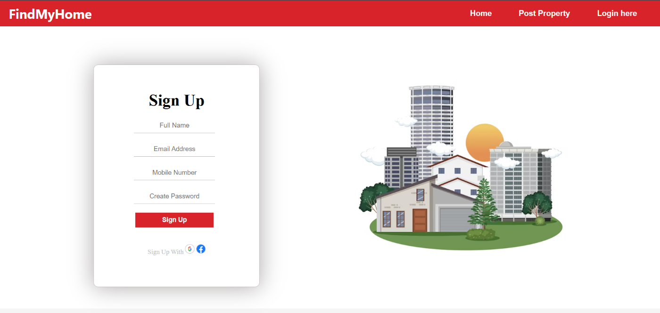

2 LOGINPAGE:

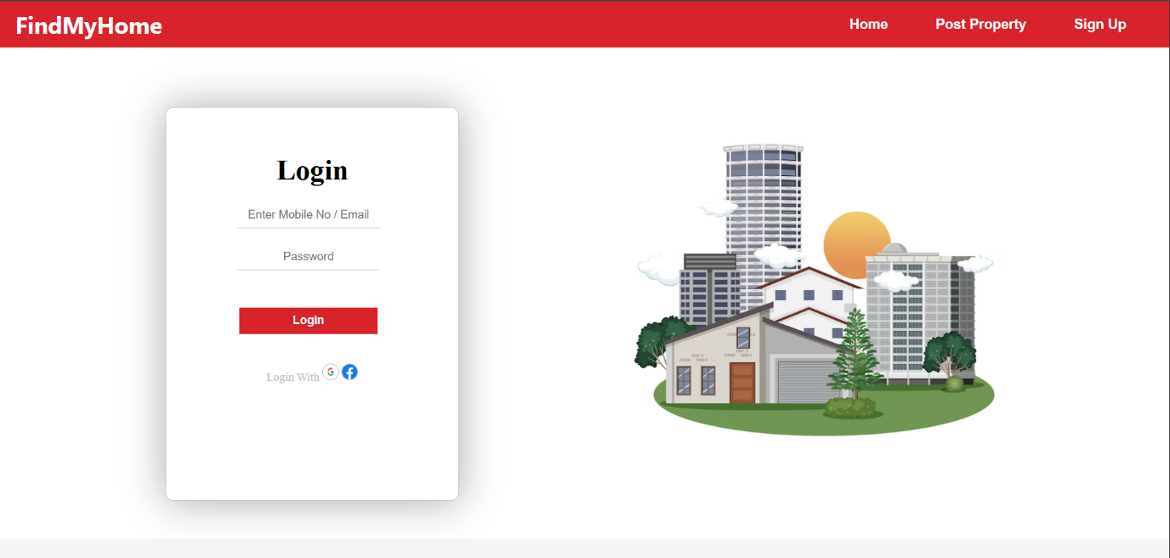

3 HOME PAGE:

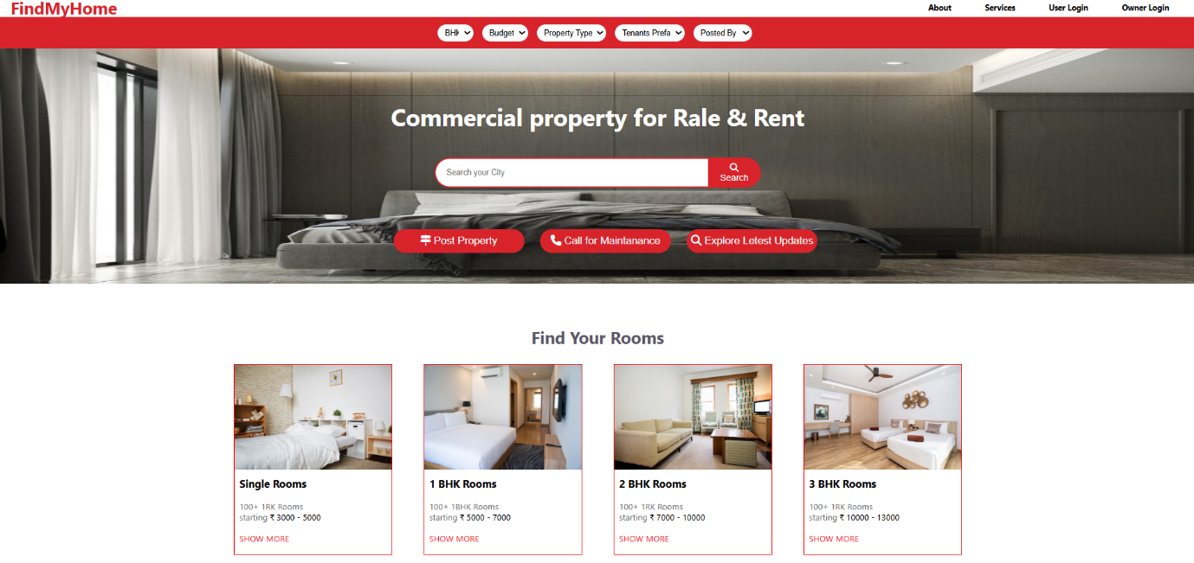

4 ROOMS PAGE:

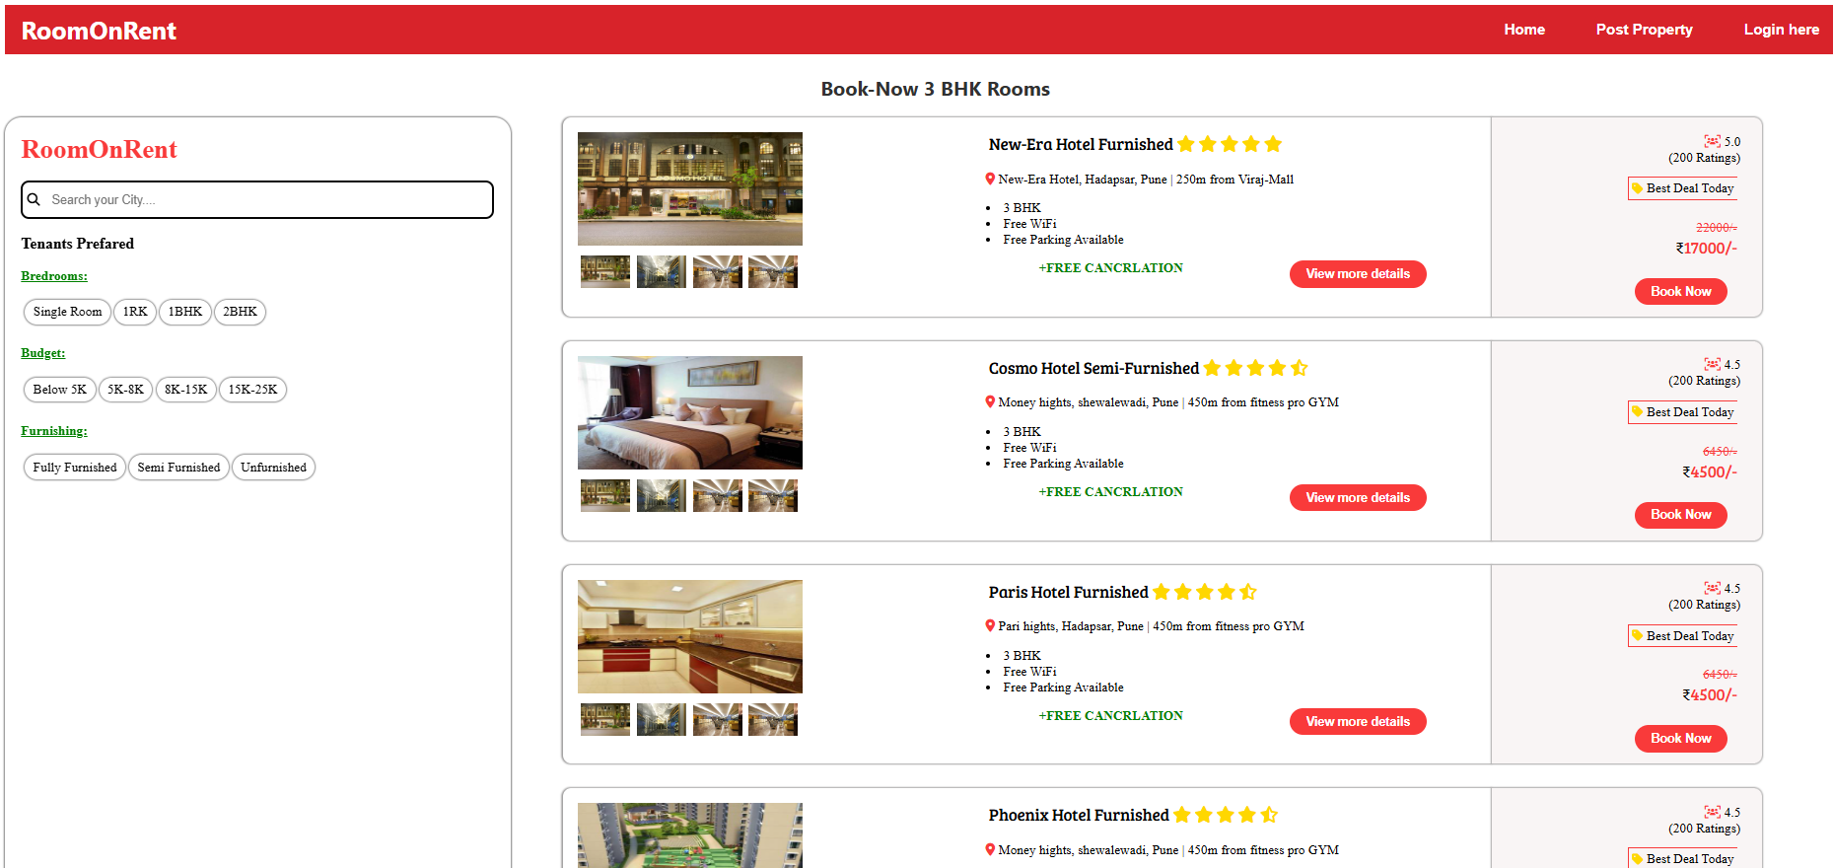

5 POST PROPERTY PAGE:

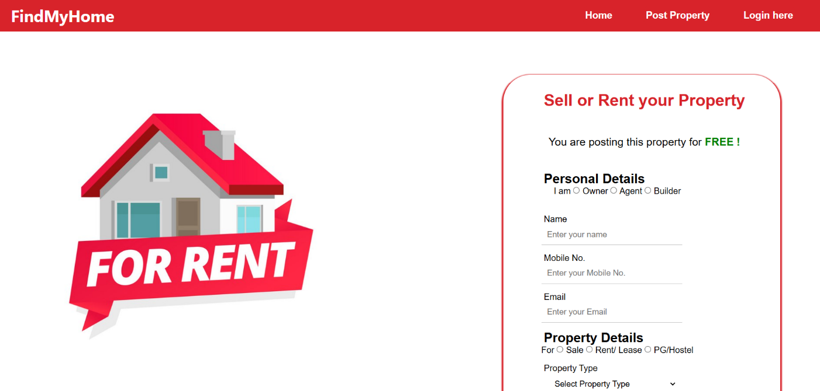

6 MAINTENANCE PAGE:

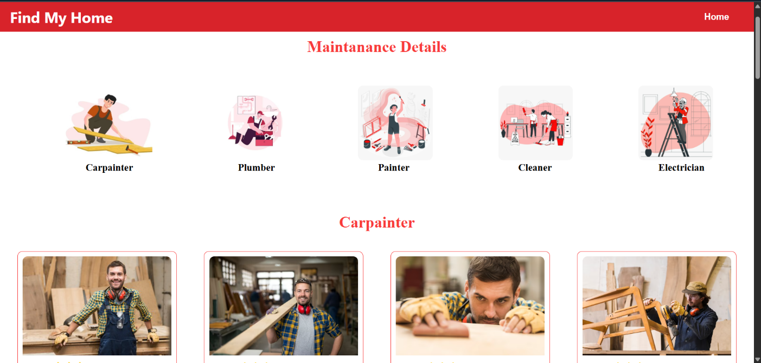

7 UPDATES PAGE:

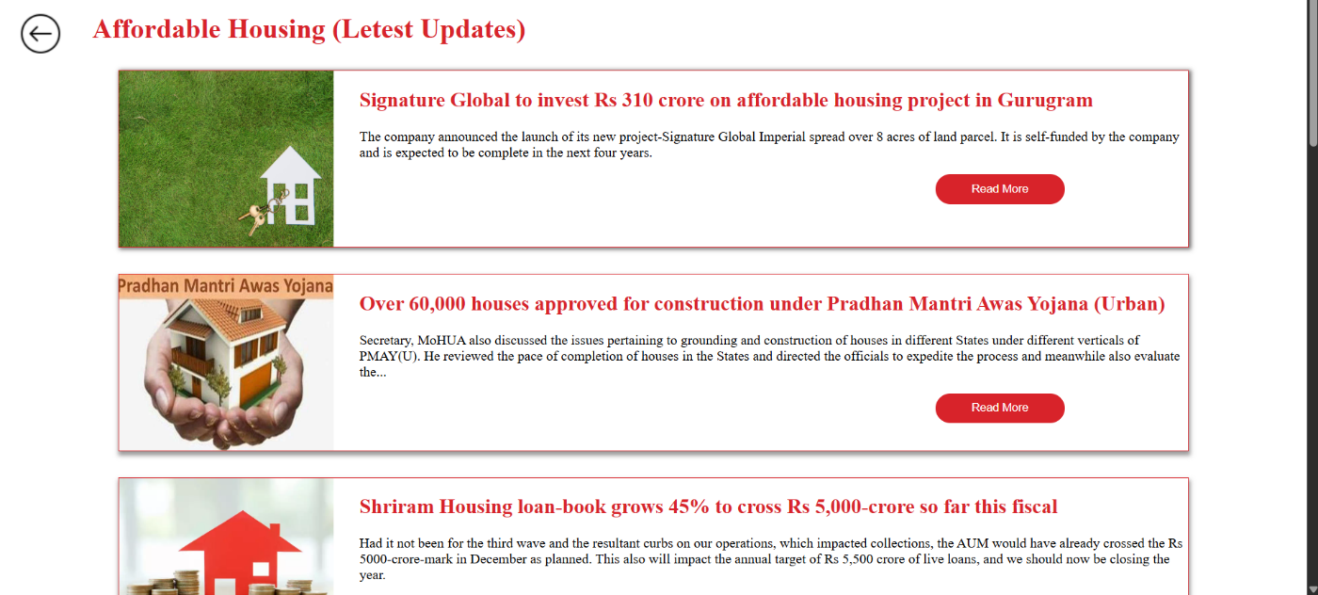

8 SINGLE ROOMS PAGE:

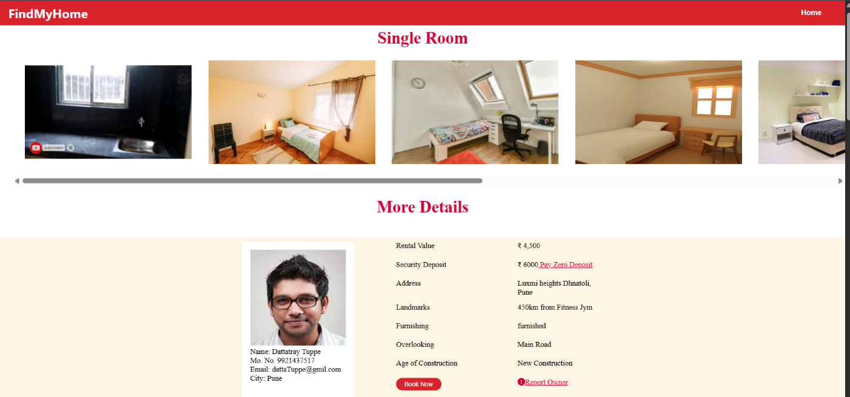

9 1 BHK ROOMS PAGE:

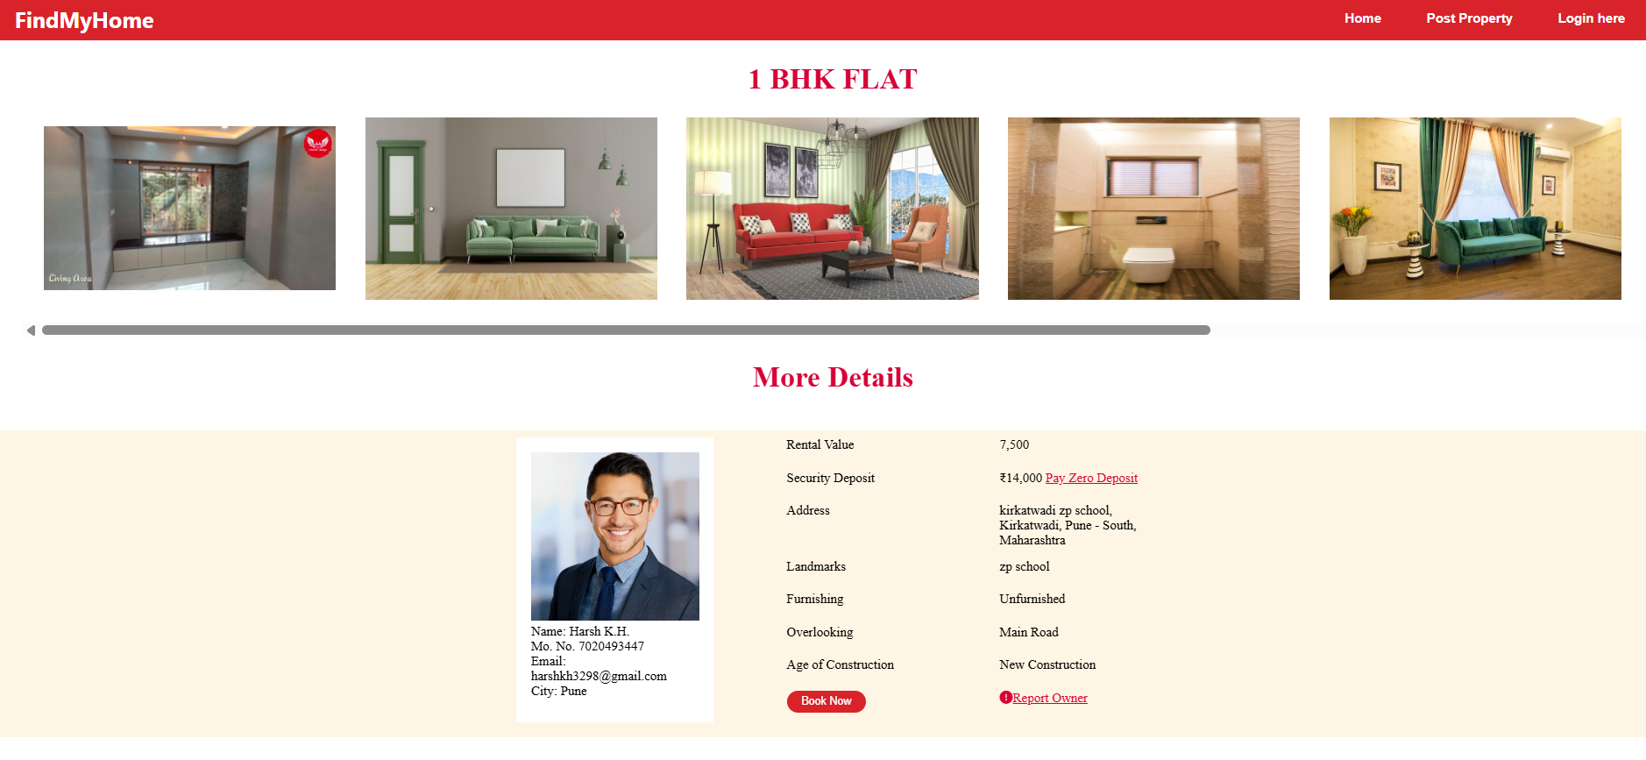

10 2 BHK ROOMS PAGE:

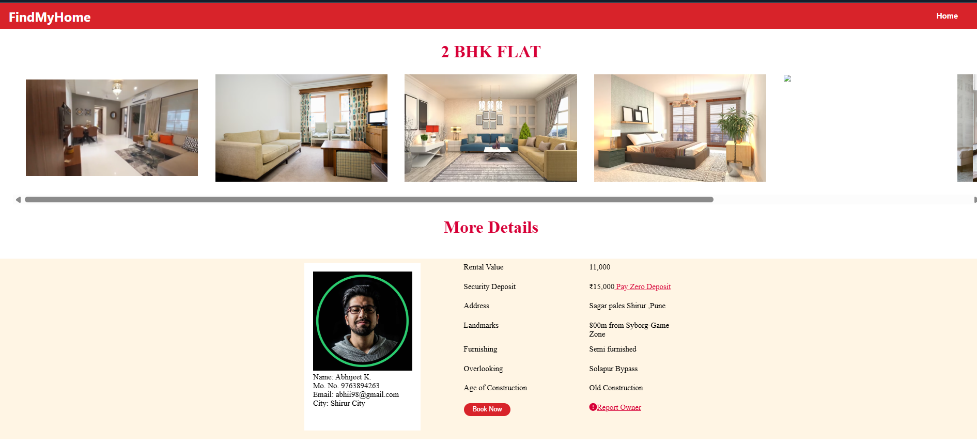

11 3 BHK ROOMS PAGE:

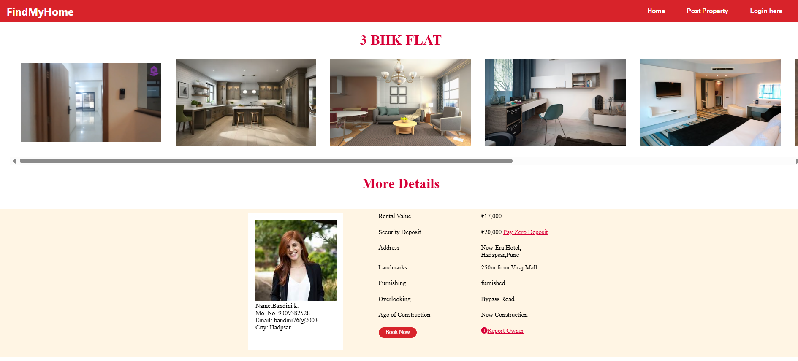

12 SERVICES PAGE:

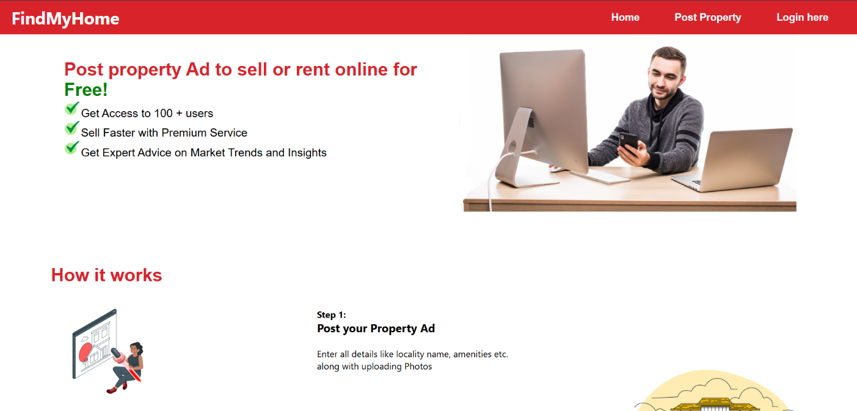

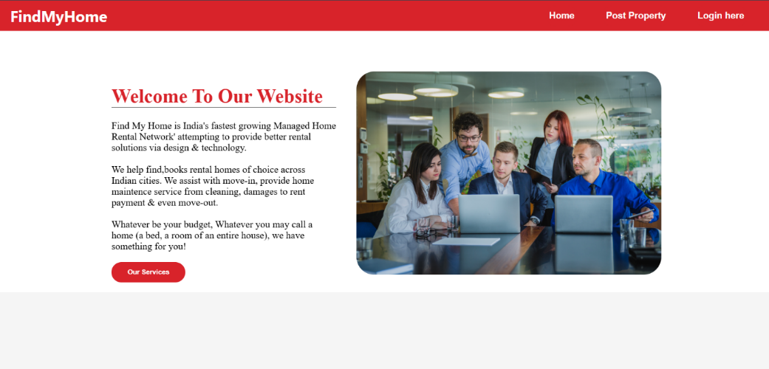
13 ABOUT PAGE:

14 BOOKING PAGE:
